Planned McNary Juvenile Fishway Temperature Probe Deployments in 2017.
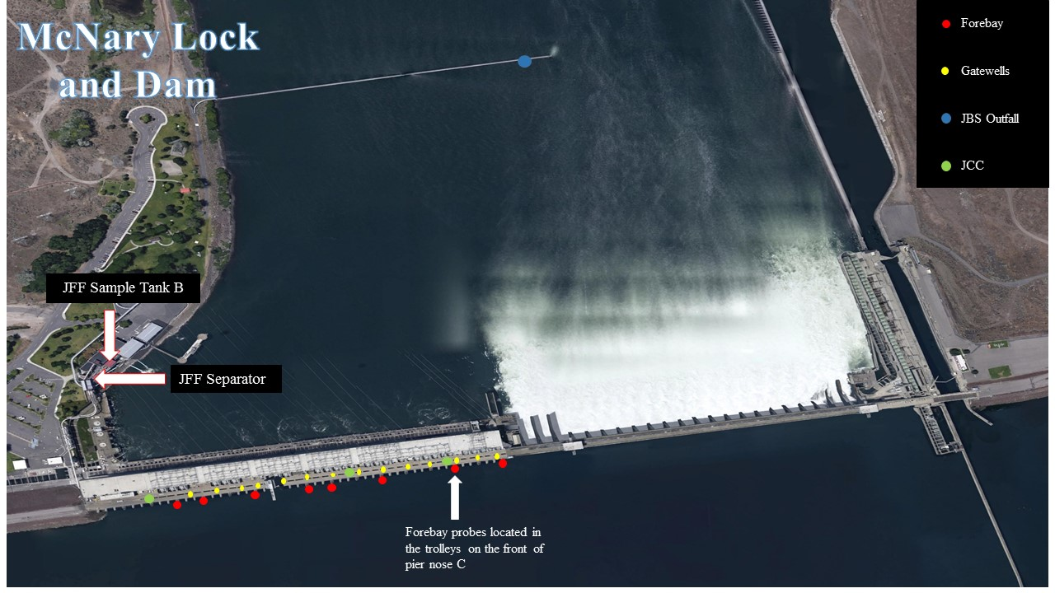
Planned 2017 Probe Locations (28 total):

Forebay (8 total):
Trolleys, Pier nose C – Units 1, 3, 5, 7, 8, 10, 12, and 14.

B slot Gatewells (14 total):
Units 1 – 14.

Juvenile Fish Facility (5 total):
Collection Channel: Units 1, 8 and 12.
Separator
Sample Tank B

Tailrace (1 total):
Juvenile Bypass Outfall

Background:
Since at least 1987, water temperatures have been measured across the powerhouse from June 15 through August 31 of each year at McNary Dam. In 2016, the contracted monitoring dates were changed to start on June 1. In 2017, the monitoring dates will return to the June 15 to August 31 timeframe. Other changes for the 2017 season include the discontinuation of forebay monitoring at spillbays 1, 7, 12, 17 and 22 and the discontinuation of tailrace temperature monitoring at the downstream navigation lock wingwall. In addition, tailrace temperature monitoring at units 1 and 14 will be shifted to the adult fishway water temperature monitoring program. The Corp of Engineers (COE) includes juvenile fishway temperature monitoring with biological services currently contracted with Anchor QEA. This monitoring is conducted to identify thermal gradients at the McNary Project that might be detrimental to juvenile fish entering the project and the fish facility. Since 1998, temperature monitoring efforts have been expanded over the full 24 hours of each day to recover temperature information using electronic temperature probes.

McNary forebay reaches or exceeds 68°F between 13 and 88 days a year. Summer winds readily mix the forebay during the majority of high air temperature days due to a steady pressure differential between coastal and interior climates. During periods of high heat, forebay water temperatures have exceeded 75.2°F, resulting in fish loss at the Juvenile Fish Facility. The cause of heat-related fish mortality is unknown, but is thought to be related to gatewell temperature differentials. When turbine units are not generating power or turned off, the water in the gatewells can cool to the temperature of deeper forebay water, which can create cold spots where the water enters the fish collection channel. Units generating power pull water from all depths, but the drawn water from near the warmer surface of the forebay moves along the turbine intake ceiling, causing temperature differentials in the depths of the gatewell that gets passed through the collection channel. In addition, the south end of the McNary powerhouse forebay tends to become warmer than the forebay at the north end of the powerhouse.

Collected information is used to guide facility and power house operations. Temperature conditions within the juvenile collection channel can be moderated by changing which turbine units are in operation. In order to minimize thermal stress on juvenile salmonids during warm water conditions, the Project Biologist may request the initiation of special turbine operations (i.e.: sawtooth pattern) when any of the following conditions occur: 1) Water temperatures in the McNary JFF sample tank >68°F; 2) Water temperatures elsewhere at the Project (e.g., gatewells) that are likely to induce thermal stress in juvenile salmonids; 3) Temperature gradients >5°F; 4) Sample mortality >3% and 5) System mortality >6%.

Available Historical Data:

Data in spreadsheet form are available for years 2000 – 2016. The 1999 spreadsheet is being compiled from daily data. 1998 daily data is available but does not cover the month of June. Data prior to 1998 is no longer in a usable format (Lotus 1-2-3).

